Reilly McBride

Period 5

16 May 2018

Unit Circle Assignment

I did hill-climbing, and was able to get to ~95% (5% error) accuracy within a reasonable amount of time when using more than 6 perceptrons (5 into 1). The algorithm was still running after this point, but seemed unlikely to get any more precise. There wasn’t a huge difference in speed or accuracy reached between 6 and 13 perceptrons, so I stopped there. I used k = 10 for the logistic curve constant, and 1 as my learning rate. This converged faster than other combinations I tried.

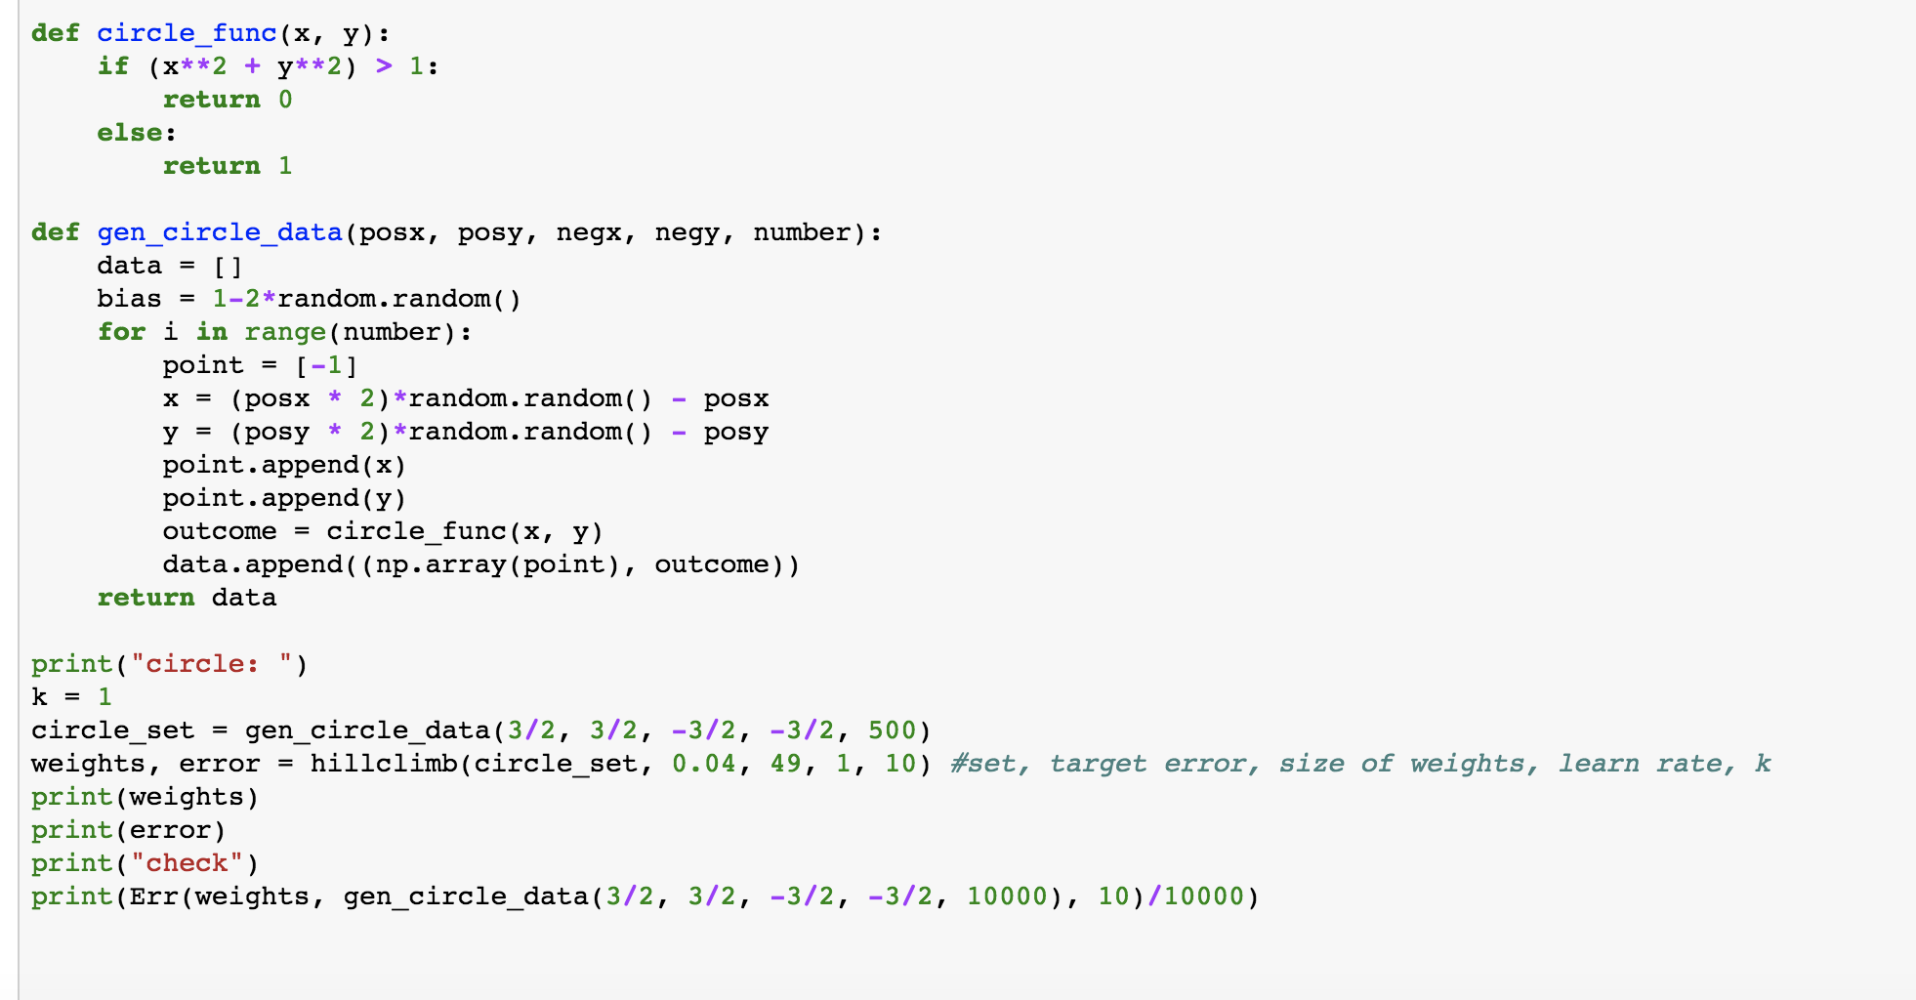

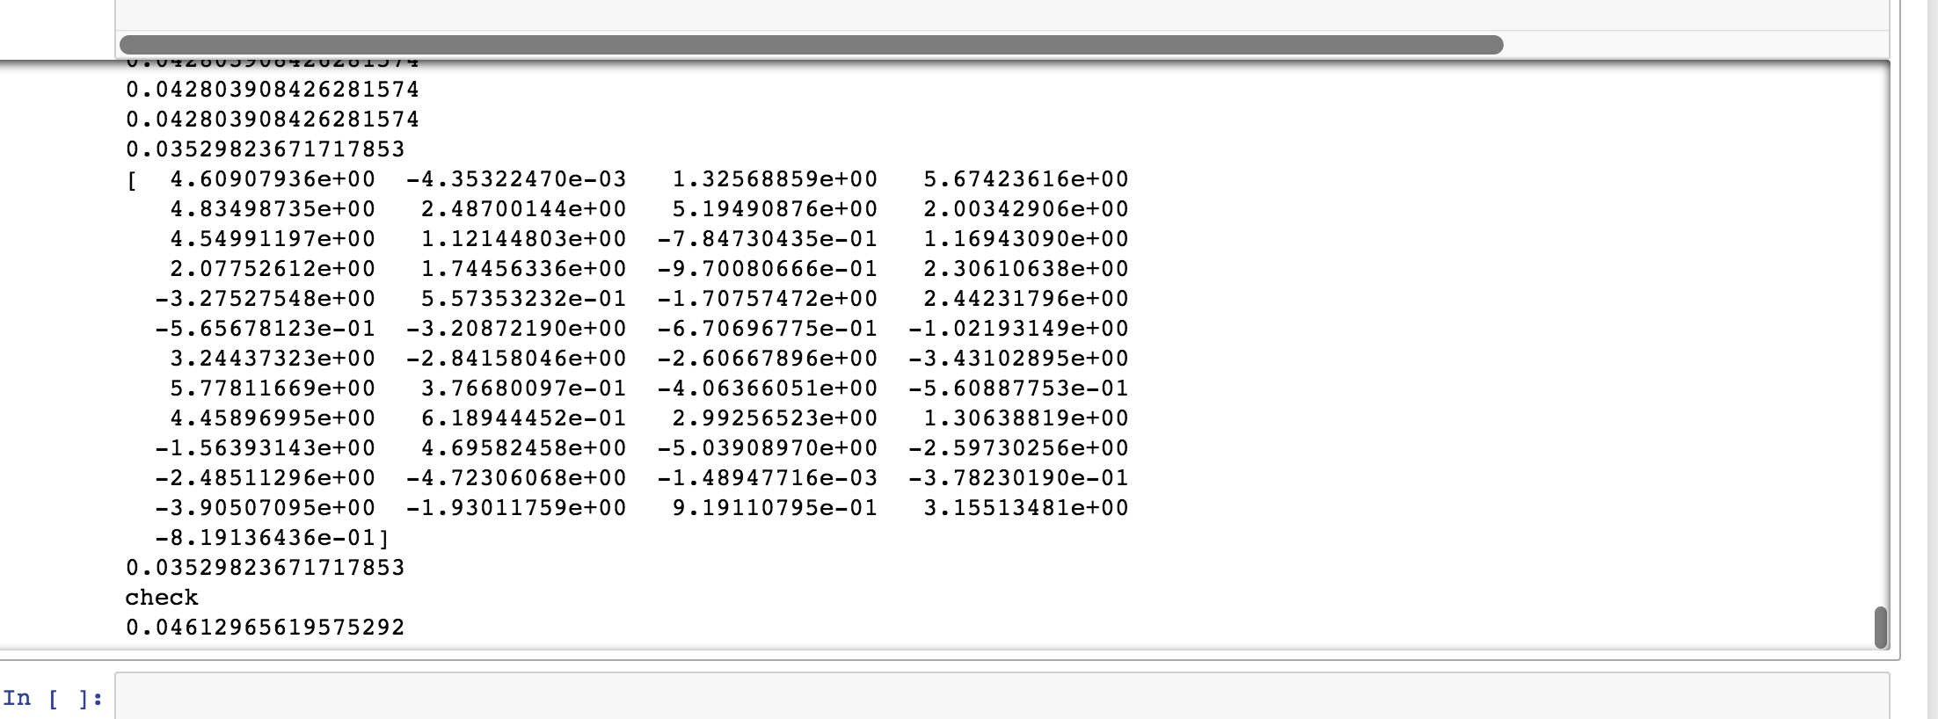

Reilly McBride

Period 5

16 May 2018

Gradient Descent Assignment:

*Function:* f(x, y) = (1 − y) ^2 + 100(x − y ^2 ) ^2

Converged at:



*Function of Choice:*

Minimum (All were close to this number to the same power of 10, with suggested error of 0.00001, all though there was slight variation since the values are so small):



When I set error to 0, values were in this range (implying it would converge at [0, 0]), and the shape of the graph did not change:



Code:

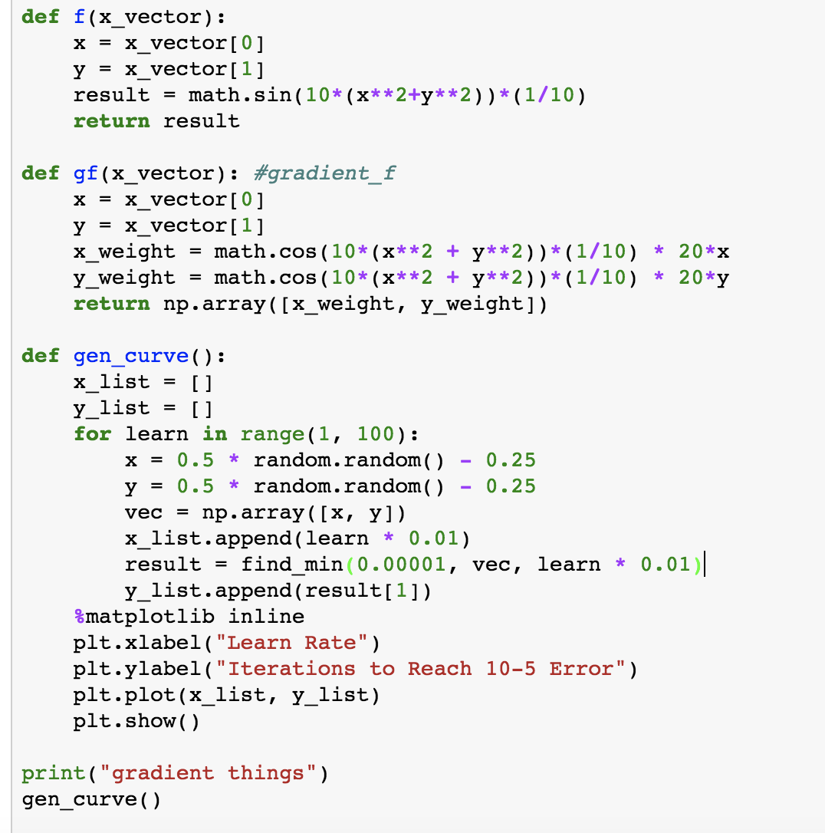

Function:

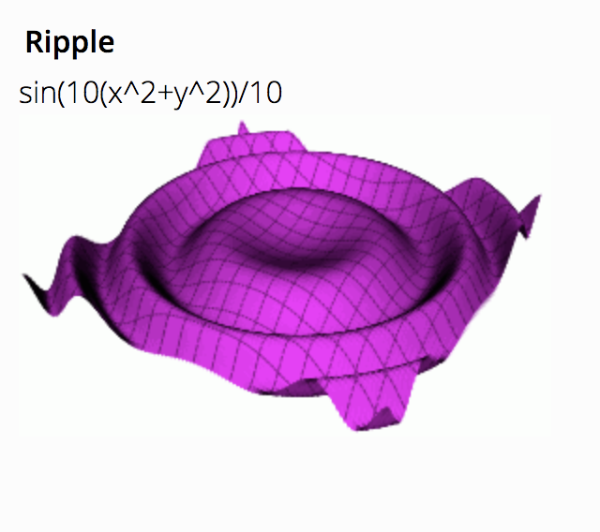

Graph:

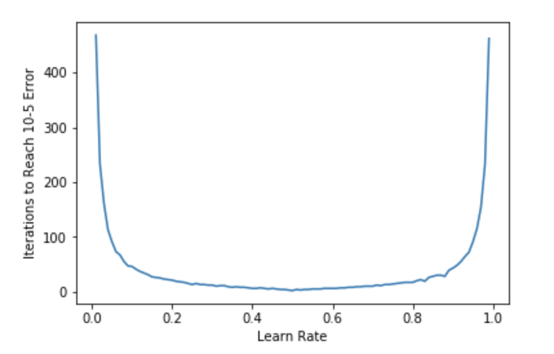

When I decreased the step size, the edges of the graph got steeper.